Soap (also called surfactant ions)
Structure:
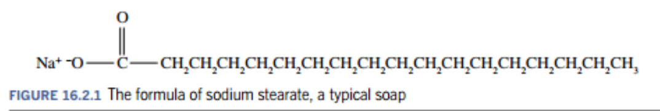
- Long chain attached to a charged end
- Ionic end (Na⁺ end) is called hydrophilic (water attracting)
- Non-polar hydrocarbon chain is hydrophobic (water hating)
- Soap solutions are basic:
  - Because soaps are the sodium salt of fatty, weak acid. They are a conjugate of a fatty acid. So when they undergo hydrolysis they from the weak acid and the OH⁻ ion. Thus the number of OH⁻ ions exceed the H⁺ ions and the solution is basic
Manufacturing process:
- Soap is formed through ester hydrolysis (specifically base hydrolysis) called saponification
- Industrially, saponification first involves boiling of fats/oils in solution of NaOH, then adding salt to mixture
- Ester hydrolysis:
  - An ester (fatty acid called triglyceride) is heated with a strong base (e.g. NaOH) in the presence of water to convert it back to the original alcohol and carboxylic acid
  - Water is used to break down the ester
  - The presence of a strong base means the carboxylic acid will be in the form of a salt and also acts as a catalyst to speed up the reaction
  - The Na⁺ attaches to the carboxylic acid and the OH attaches to the rest to form the primary alcohol
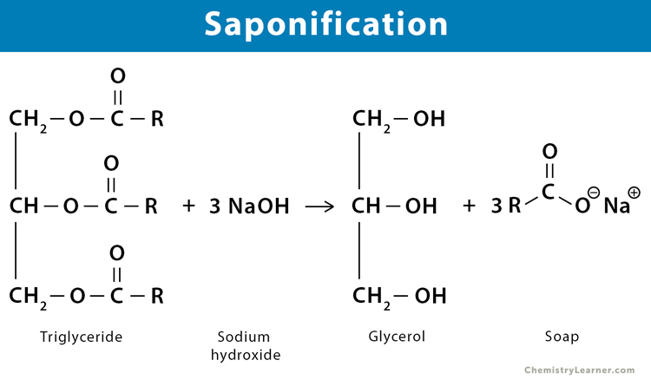
- Saponification:
  - Ester used is tristearin (animal fat) and the salt produced is sodium stearate (soap) along with a by-product called glycerol (which is a tri-alcohol)
  - To change the physical properties of the soap produced, different strong base is used instead of NaOH
    - NaOH – soap produced is soft and used in typical bar soap
    - KOH – soap produced is liquid (softer) and has a low melting point
    - Li(OH)₂ – soap produced is solid and has high melting point
    - Ca(OH)₂ / Mg(OH)₂ – soap produced is insoluble
- Air bubbles added to molten soap will decrease the density of the soap and allow it to float on water
- With the fatty acids, the most important characteristic is the chain length. As it increases, it becomes more non-polar, less soluble in water, they become harder and don’t lather easily. Level of saturation also affects properties, more unsaturated fatty acids tend to make soaps softer and more water soluble
How soap acts as cleaning agent:
- Hydrophobic tail gets attracted to the non-polar greasy material (e.g. oil)
  - The hydrophobic end are also attracted to each other
  - This happens via dispersion forces since it’s non-polar
- Hydrophilic head gets attracted to the water molecules
  - This happens via ion-dipole forces
- These attractions causes soap to form small compact spherical structures called micelles
  - Inside is the greasy non-polar substance attached to the hydrophobic tail of the soap ion
  - Outside is the water molecules attached to the hydrophilic end of soap ion
- When the hydrophobic tail gets embedded inside the micelle, it is stabilised in the water
- This allows the polar solvent water (on the outside of the micelle) to dissolve the insoluble non-polar substance
- The cleaning action is enhanced by agitation (e.g. rubbing your hands together) and using hot water
Advantages of soap:
- Cheap and readily available
- Works well in soft water
- Are 100% biodegradable
Limitations of soap:
- Water containing calcium ions and magnesium ions is known as hard water
- The cleaning action of soaps is prevented in the presence of hard water
- The ions (Ca²⁺, Mg²⁺) react with soap ions in a precipitation reaction to form insoluble substances resembling a floating scum
- Effect of using soap in hard water:
  - Poorly washed clothes
  - Blocked drains from scum
  - Grey scum in wash tubs
  - Unsightly stains around basin and taps
- Metal ions can be removed by adding other negative ions, such as carbonate ions, to the soap. The carbonate ions soften the water precipitating the magnesium ions as magnesium carbonate.
- Soaps are less effective in saline (sodium chloride) water and acidic water
  - This is because the hydrophilic end of soap interacts with water by ion-dipole interactions
  - The Na⁺ and Cl⁻ in saline water and the H⁺ in acidic water also interact with water via ion-dipole interactions
  - Hence there is less water molecules available for the hydrophilic end to interact with and therefore causes the soap to be less effective because without interaction with water molecules, the micelles can’t break the oil molecule and wash them away
- Soap is not suitable for washing woollen garments because it is basic in nature and woollen garments have acidic dyes

Detergents
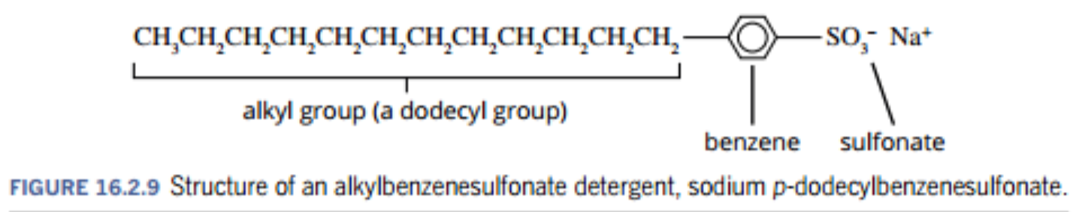
Structure:
- They are similar to soap but have a different structure and do not form a precipitate in hard water, because the polar sulfonate is less likely to bind to ions in hard water than the polar carboxylate in soaps
- Detergents are sourced from petrochemicals and have similar cleaning mechanism to soaps because their structures have the same features
- Most detergents are alkylbenzene sulfonates
Types of detergents:
- Anionic
- Have net negative electrical charge
- Linear and branched alkyl groups can be used but linear alkyl groups are more likely to be biodegradable
  - Branched had better tolerance to hard water and better foaming
- Cationic
  - Have a net positive electrical charge
  - Chemical structure is similar to anionic detergents but instead of the anionic sulfonate group, they have quaternary ammonium as the polar end
- Non-ionic
  - Contain an uncharged hydrophilic end (non-polar)
- Zwitterionic
  - Have equal numbers of +1 charge and -1 charge so have a net charge of 0
Manufacturing process:
- Manufacture of detergent can be acheived by reacting an alkylbenzene with concentrated sulfuric acid, followed by sodium hydroxide – detergents are thus the salts of alkylbenzenesulfonates
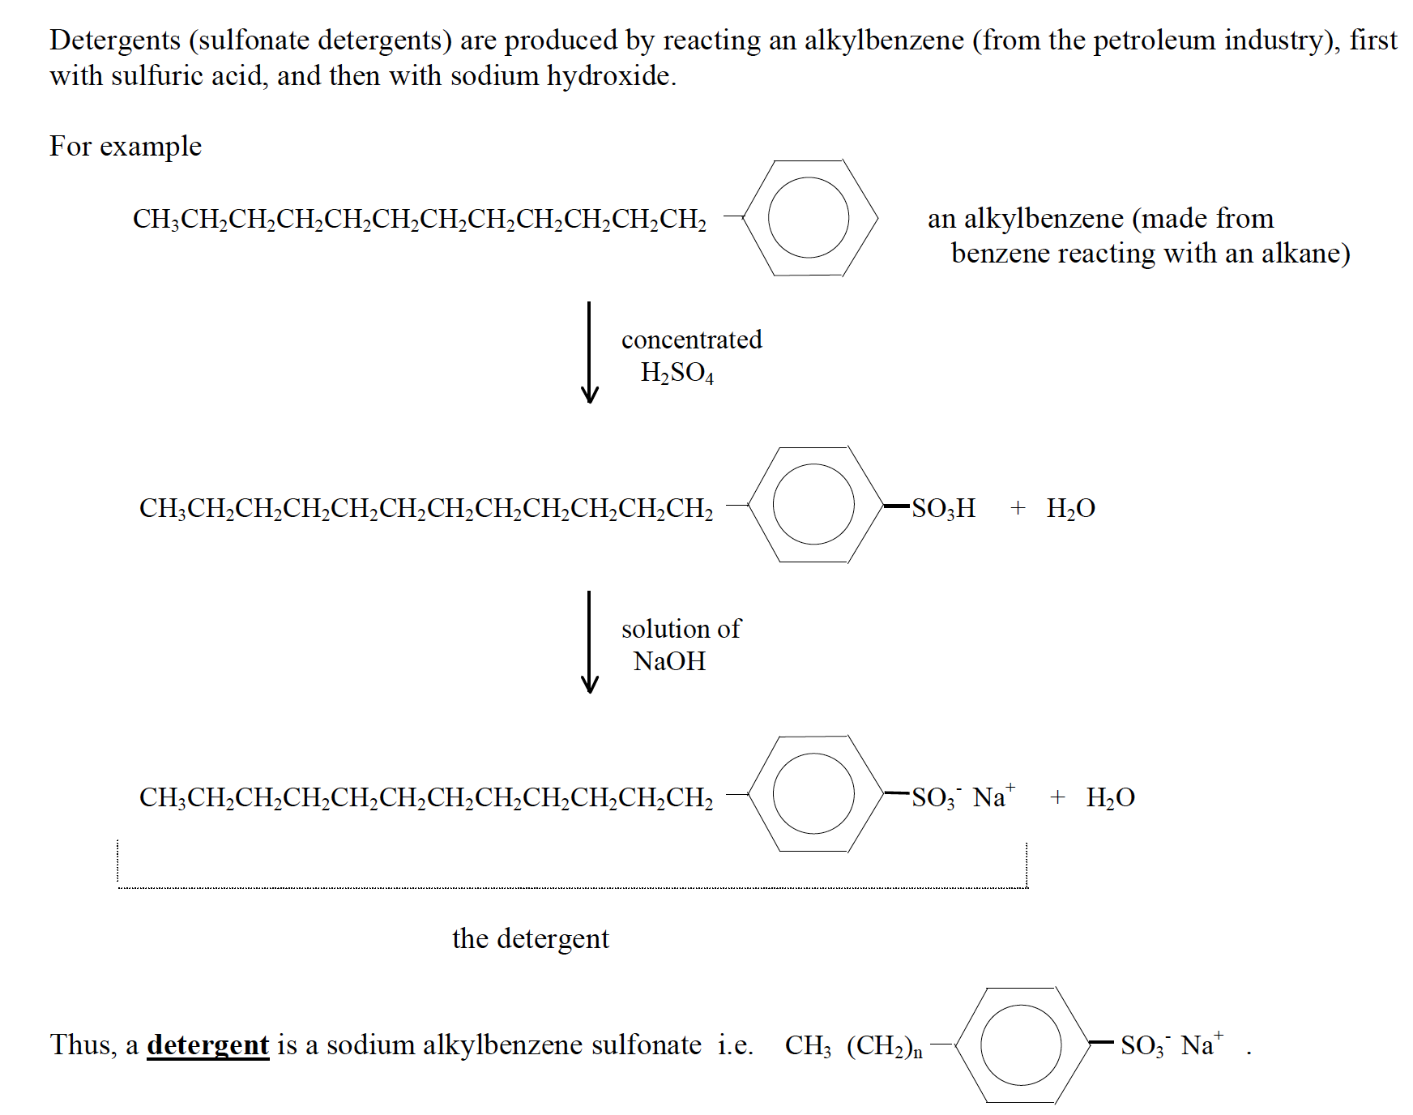
How they act as cleaning agents:
- Same as soaps
Advantages of detergents:
- They work in hard, saline, and acidic water
- They have a stronger cleansing action than soap
- Linear hydrocarbon chains are biodegradable
Limitations of detergents:
- Branched hydrocarbon chains are non-biodegradable
- They cause soil pollution and water pollution
Soaps | Detergents
Cannot be used in hard water | Can be used in hard water
Made from expensive vegetable oils | Made from by-products of petroleum industry
Cannot be used in acidic medium as this would precipitate fatty acids | Can be used in any medium including acidic mediums
Weak cleansing action | Strong cleansing action
Not very soluble in water | Highly soluble
Biodegradable and do not cause any pollution | Some are not biodegradable and may cause water pollution

